|  |  |  |
| --- | --- | --- |
| **Memorandum** | Columbia Public Schools  Business Services  (573) 214-3700 | CPSSEAL |

DATE: January 30, 2017

## **TO**: all staff

FROM: Doug Boyer

RE: Amazon charging Missouri Sales Tax

|  |
| --- |
|  |

Many have heard the news that Amazon will begin charging sales tax on February 1, 2017, for orders placed in Missouri. We understand a warehouse will be built soon which would place Amazon inside our state lines for the first time and require them to charge 4.225% sales tax on our orders.

In order to circumvent issues with Amazon collecting sales tax on our orders, we’ve applied and been accepted into the Amazon Tax Exemption Program (T.E.P.) for users who are currently enrolled in the CPS Amazon Business account.

To create a CPS Amazon Business Account, contact the Purchasing Card Administrator – Doug Boyer via email at DBoyer@cpsk12.org. You’ll then receive an email from Amazon inviting you to set up your account.

Points of emphasis:

* CPS is exempt from paying sales tax in Missouri and will not reimburse sales tax paid by an employee to Amazon or any other vendor. Also, sales tax is an unallowable charge on the purchasing card.
* The CPS Amazon Business Account has been approved in the Amazon Tax Exempt Program which allows us to make qualified tax exempt purchases fulfilled or placed with Amazon.
* Amazon Marketplace vendors who do not have a location in Missouri, should NOT be charging tax. This is currently the case and should carry forward without change.
* Marketplace vendors that are located in Missouri should already (and will continue to) charge sales tax. If the Marketplace vendor is a member of Amazon’s Tax Exempt Program, the transaction will automatically be tax exempt under our Amazon Business Account. If you notice a Marketplace vendor that does charge sales tax, Amazon has provided an email address for us to inform so they can refund the sales tax.
* Personal Amazon memberships are not allowed to have the CPS sales tax exemption on their account.
* Only business-related purchases are allowed under the CPS Amazon Business account.
* Any Amazon orders that have sales tax charged will still be the cardholder’s responsibility to have refunded or reimbursed.
* The user needs to be diligent when selecting where items are ordered to ensure they are sales tax exempt so that refunds and reimbursements are not needed.
* If you are purchasing an item that is available through multiple vendors, these are the locations on the item page where you can review if it is coming from Amazon or a 3rd party vendor:
  + Notice the highlighted words below “Ships from and Sold by Amazon”. This item would be tax exempt.

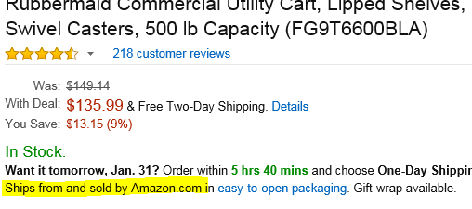

* + The item below is Fulfilled by Amazon meaning it would be tax exempt.

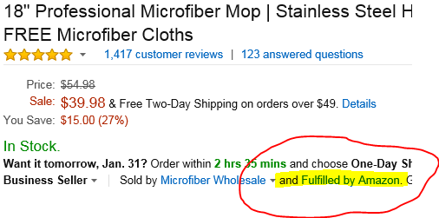

This specific item can be purchased two ways:

A. Through the seller directly – if they have a location in Missouri they may try to charge you sales tax unless you contact the seller directly to send a copy of our Tax Exempt Certificate.

B. Or, you can order the item through the Amazon Fulfillment location (highlighted below) and not be charged sales tax since it is under our CPS Business Account.

